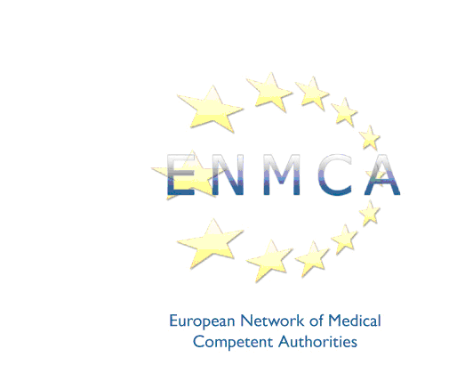
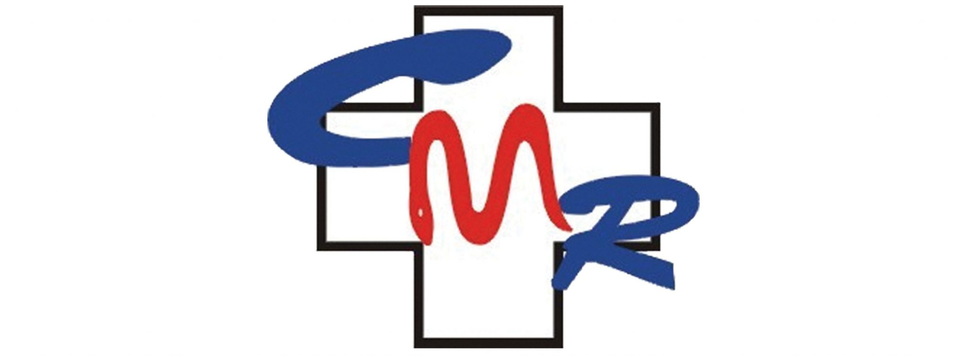

33rd meeting of the
European Network of Medical Competent Authorities

Hosted by the Romanian College of Physicians

Union Plaza hotel, 47c Bulevardul Unirii, Bucharest

Friday 20 June 2025

Please return this registration form by email to the ENMCA secretariat at contact@enmca.eu no later than Friday 9 May 2025

I would like to attend the meeting on Friday 20 June 2025

Name
Title
Competent Authority
Address
Telephone
Email

I will attend the dinner offered by the Romanian College of Physicians on Thursday 19 June:

YES / NO (please delete)

Please indicate in the box below whether you have any dietary or special requirements:

